Index

| Sr No. | Title | Pg No. |
| --- | --- | --- |
| 1 | MODULE 1:Login and Sign up | 2 |
| 2 | MODULE 2:Dashboard | 6 |
| 3 | MODULE 3:Category Page |  |
| 4 | MODULE 4:Cart page |  |
| 5 | MODULE 5:Order status Page |  |
| 6 | Nestify Living in Flutter |  |

| Module 1-Login and Signup | | | | |
| --- | --- | --- | --- | --- |
| Sr No | Company | Functionality | Control | Validation |
| 1 | Ajio | -For SignUp  User have to enter their mobile number,the user is validate by OTP  After User has to Enter their name,Select Gender,Enter Email address.User can also create a new account by google or facebook account.  -For SignIn  For signIn user enter their number after OTP validation user get login or signIn. | 1. Signup:  -Phone number(Number Input)  -Name(Text input)  -Gender(Radio Button)  -Email(Text input)  -Agree to T/C(check box)  -Continue to phone verification(Button)  2.Authentication:  - Enter OTP(tel input)  3.SignIn/Login:-  -Enter mobile Number(number input)  -Send OTP(Button)  -Enter OTP(Tel Input) | -Sign Up  For signUp user first enter the number after click on continue button user is validate that this user is already exist or not if user is exist then it goes for OTP validation.If user not exist then it will going for user’s information form and there it will take user’s name,email,gender.After enter all details user is validate by OTP. |
| 2 | Nykaa | -SignUp:-  User have to enter their mobile number,the user is validate by OTP  After User has to Enter their name,Select Gender,Enter Email address.User can also create a new account by google or facebook account.  -SignIn:-  For signIn users enter their number after OTP validation user get login or signIn. | 1.Signup:  Email Text input)  Name(Text input)  Mobile Number(number input)  2.Authentication:  OTP(tel input)  Get started(button)  3.Login:  Email(Text input)  2.Authentication:  OTP(tel input)  Continue(button) | -To sign up user have to provide email or mobile if you have never registered it will show sign up menu otherwise login menu  -validate the email id by checking @ in the input and give alert”Enter valid email”  -checks mobile number is its less than 10 or more than that it will show “Enter a valid mobile number”  -After filling all details, Users get an OTP,if user type correct OTP user is authenticated |
| 3 | Myntra | -To Sign up  Users have to enter their mobile number after that user gets OTP which they want to enter.  After that, users have to enter their name. | 1. Signup:  Mobile Number(Text input)  verification(Button)  Name(Text input)  2.Authentication:  OTP(text input)  Verify(button)  3.Login:  Mobile Number(Text input)  OTP(tel input  Login(Button) | In Sign Up first user have to enter the mobile number then it validate the user if it exist then it goes to sign in process otherwise it goes to signup process  Then the user has to enter the name and it’s done. |
| 4 | Tata Cliq | -To Sign up  Users have to enter their mobile number after that user gets OTP which they want to enter.  After that, users have to enter their name. | 1. Signup:  Mobile Number(Text input)  verification(Button)  Name(Text input)  2.Authentication:  OTP(text input)  Verify(button)  3.Login:  Mobile Number(Text input)  OTP(tel input  Login(Button) | In Sign Up first user have to enter the mobile number then it validate the user if it exist then it goes to sign in process otherwise it goes to signup process  Then the user has to enter the name and it’s done. |
| 5 | Craftsvilla | -To signup and login is done by mobile number only  -By sending OTP, User is  Authenticate  -After authentication user have to filll full name and email | 1.Login/signup  Mobile number(Text input)  Continue(Button)  2.Authentication:  OTP(text input)  Verify(button) | -In sign up it checks if the number is not less than or more than 10  -Users get an OTP,if user type correct OTP user is authenticated |

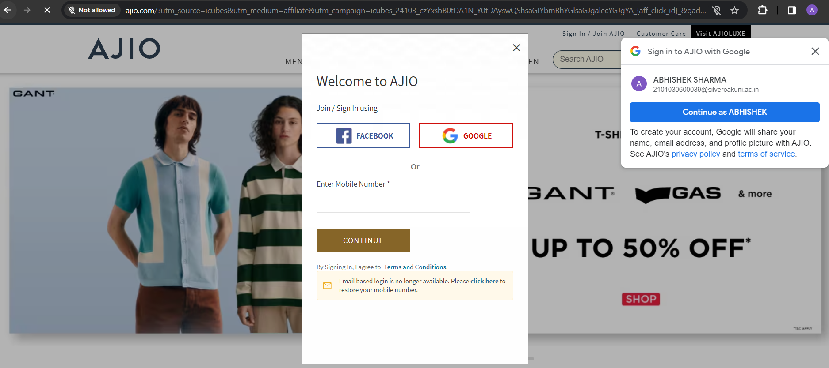

AJIO

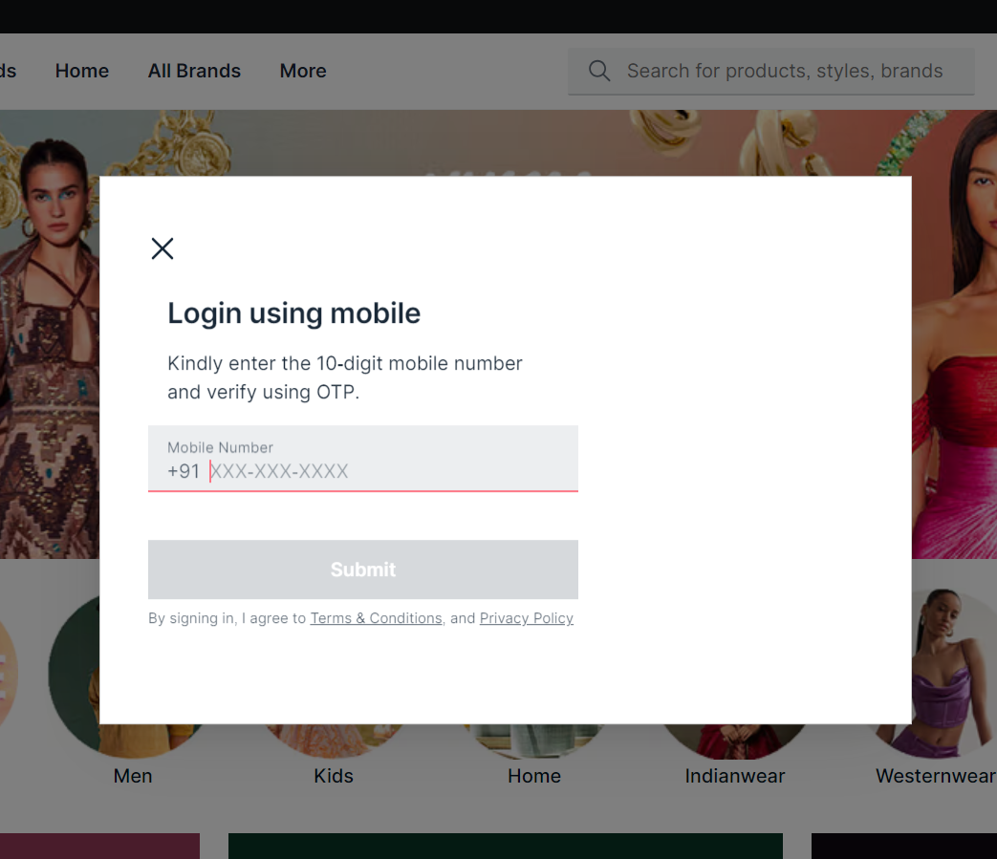

NYKAA

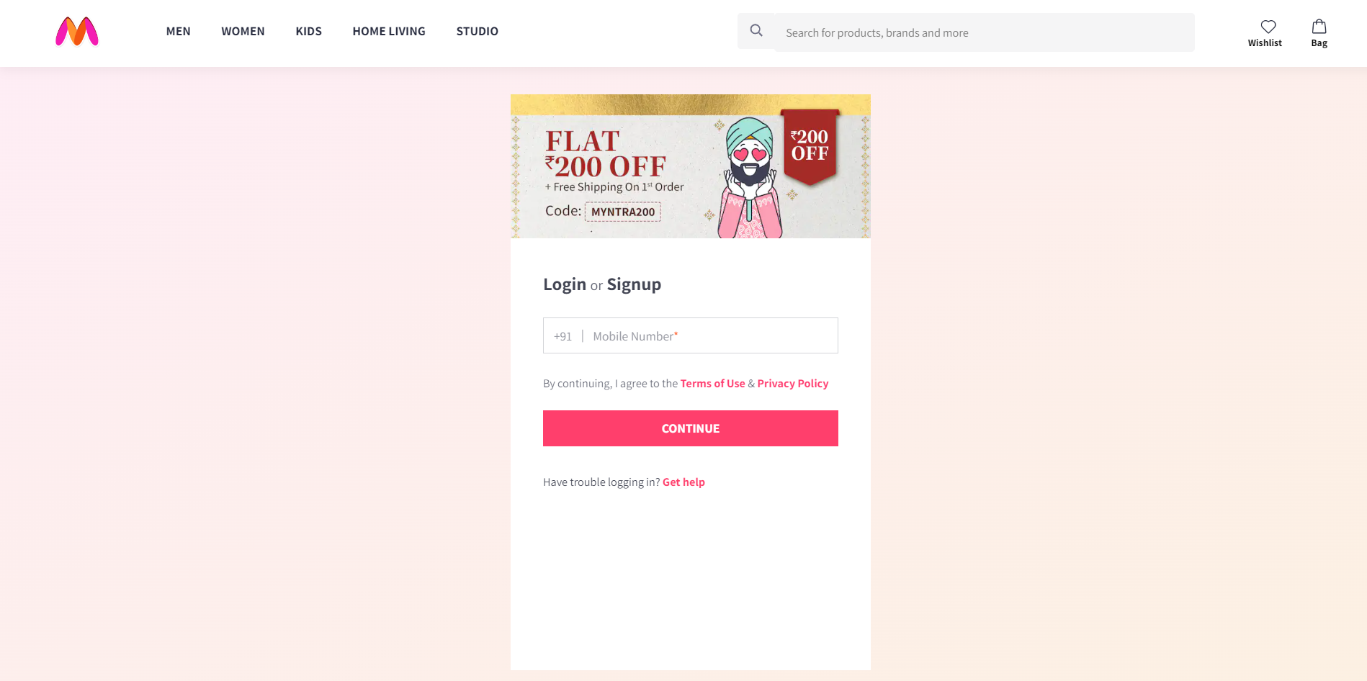

MYNTRA

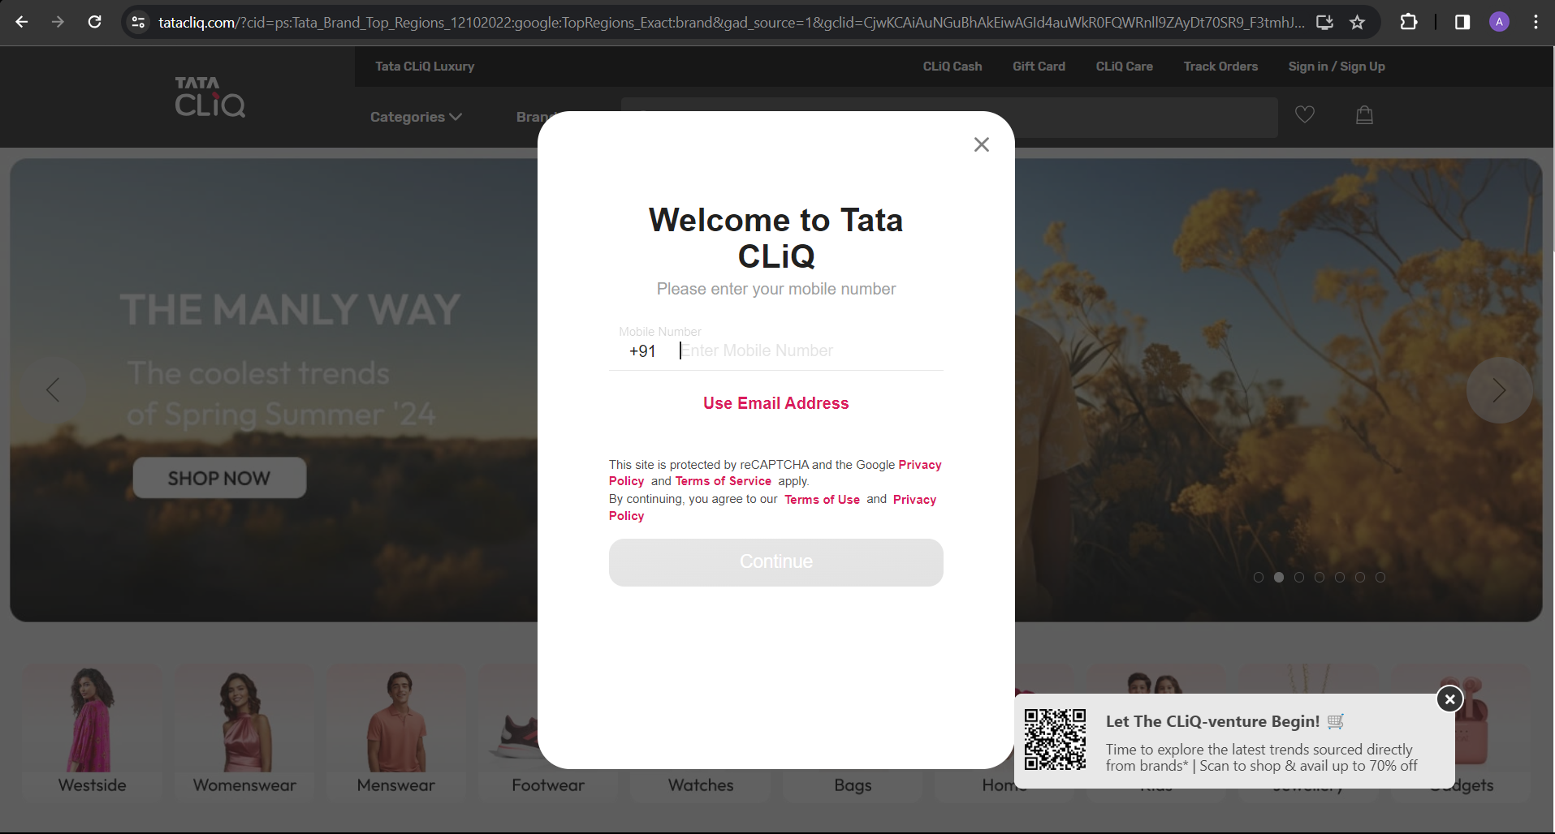

TataCliq

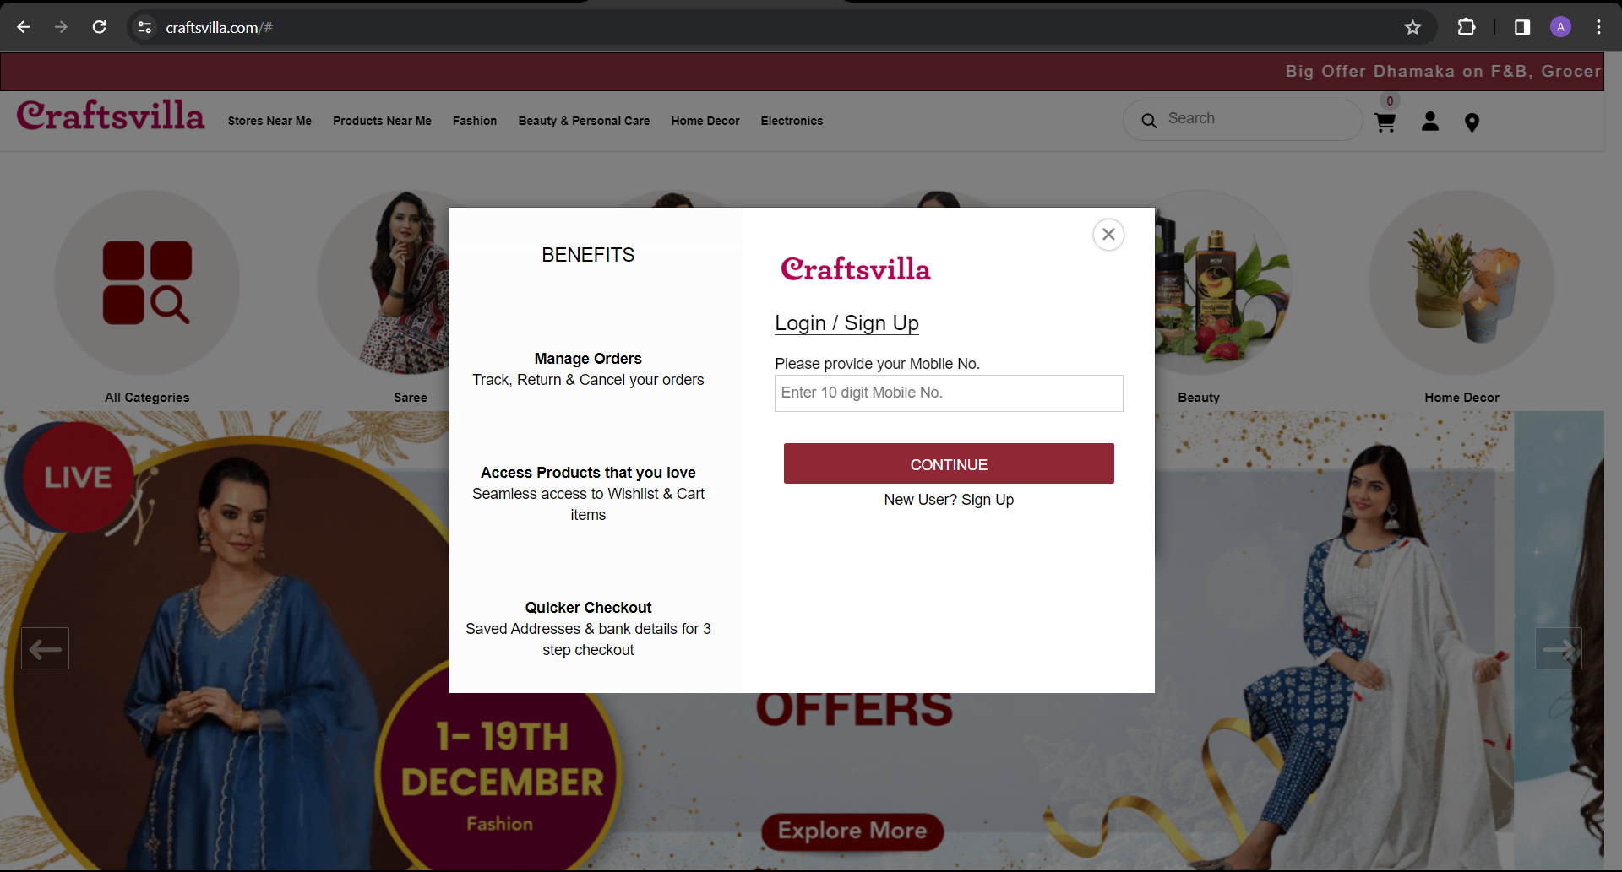

Craftsvilla

| Module- 2 Dashboard page | | | | |
| --- | --- | --- | --- | --- |
| Sr No | Company | Functionality | Control | Validation |
| 1 | AJIO | Dashboard is the main page where users see the different categories like search bar,categories of products,hover property on categories where users see the list of subcategories,links for different categories. | Search bar(search type)  Categories like  kids,gents,ladies,cotton(links on images)  categories(links,hover properties)  signin/signup(link)  cart(link)  wishlist(link) | -On the dashboard the product price is shown based on the locality or area.  -When a user searches the product, in the backend it verifies that from which country or city the user is requesting. |
| 2 | NYKAA | On the dashboard users can see different categories like search bar,categories of products,hover property on categories where users see the list of subcategories. | -account(button)  -wishlist(button)  -categories(links/hover)  -Brand logo(img)  -search bar(search)  -cart(button)  -images(img with links) |  |
| 3 | MYNTRA | On the dashboard users can see different categories like search bar,categories of products,hover property on categories where users see the list of subcategories. | -profile(button)  -wishlist(button)  -categories(links/hover)  -Brand logo(img)  -search bar(search)  -bag(button)  -images(img with links)  -latest offer(button) |  |
| 4 | TataCliq | On the dashboard users can see different categories like search bar,categories of products,hover property on categories where users see the list of subcategories. | -username(drop down)  -wishlist(button)  -categories(links/hover)  -brands(text/link)  -Brand logo(img)  -search bar(search)  -cart(button)  -images(img with links)  -gift card(text/link)  Order track(text/link) |  |
| 5 | Craftsvilla | On the dashboard users can see different categories like search bar,categories of products,hover property on categories where users see the list of subcategories. | -notifications(marque)  -categories(img/link)  -brands(img/links)  -cart(button/link)  -profile(button)  -Store near me(text/link)  -Search bar(search)  -websites logo(img) |  |

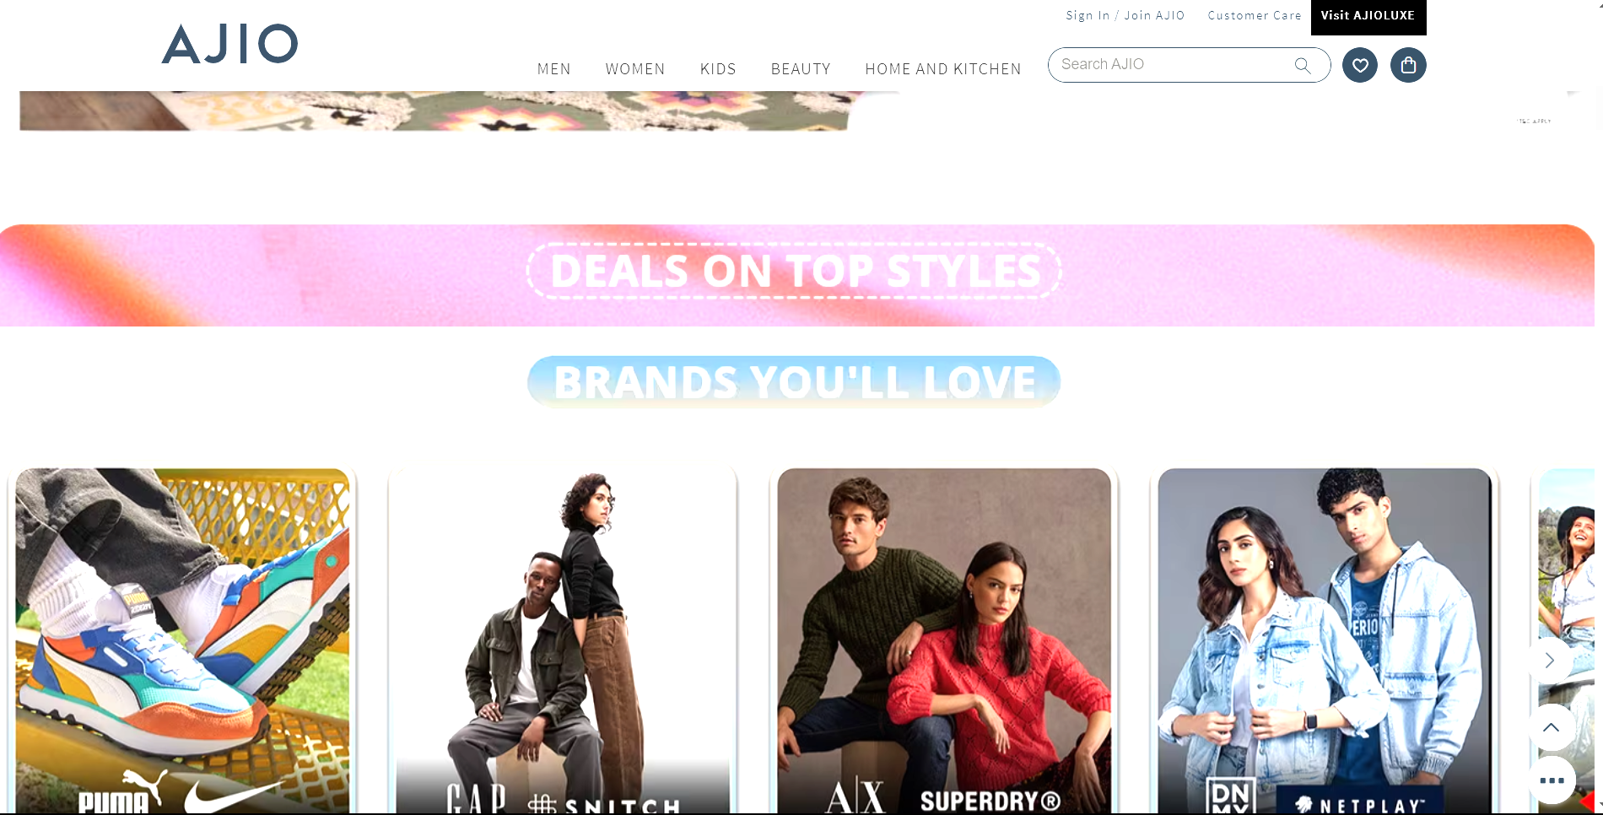

AJIO

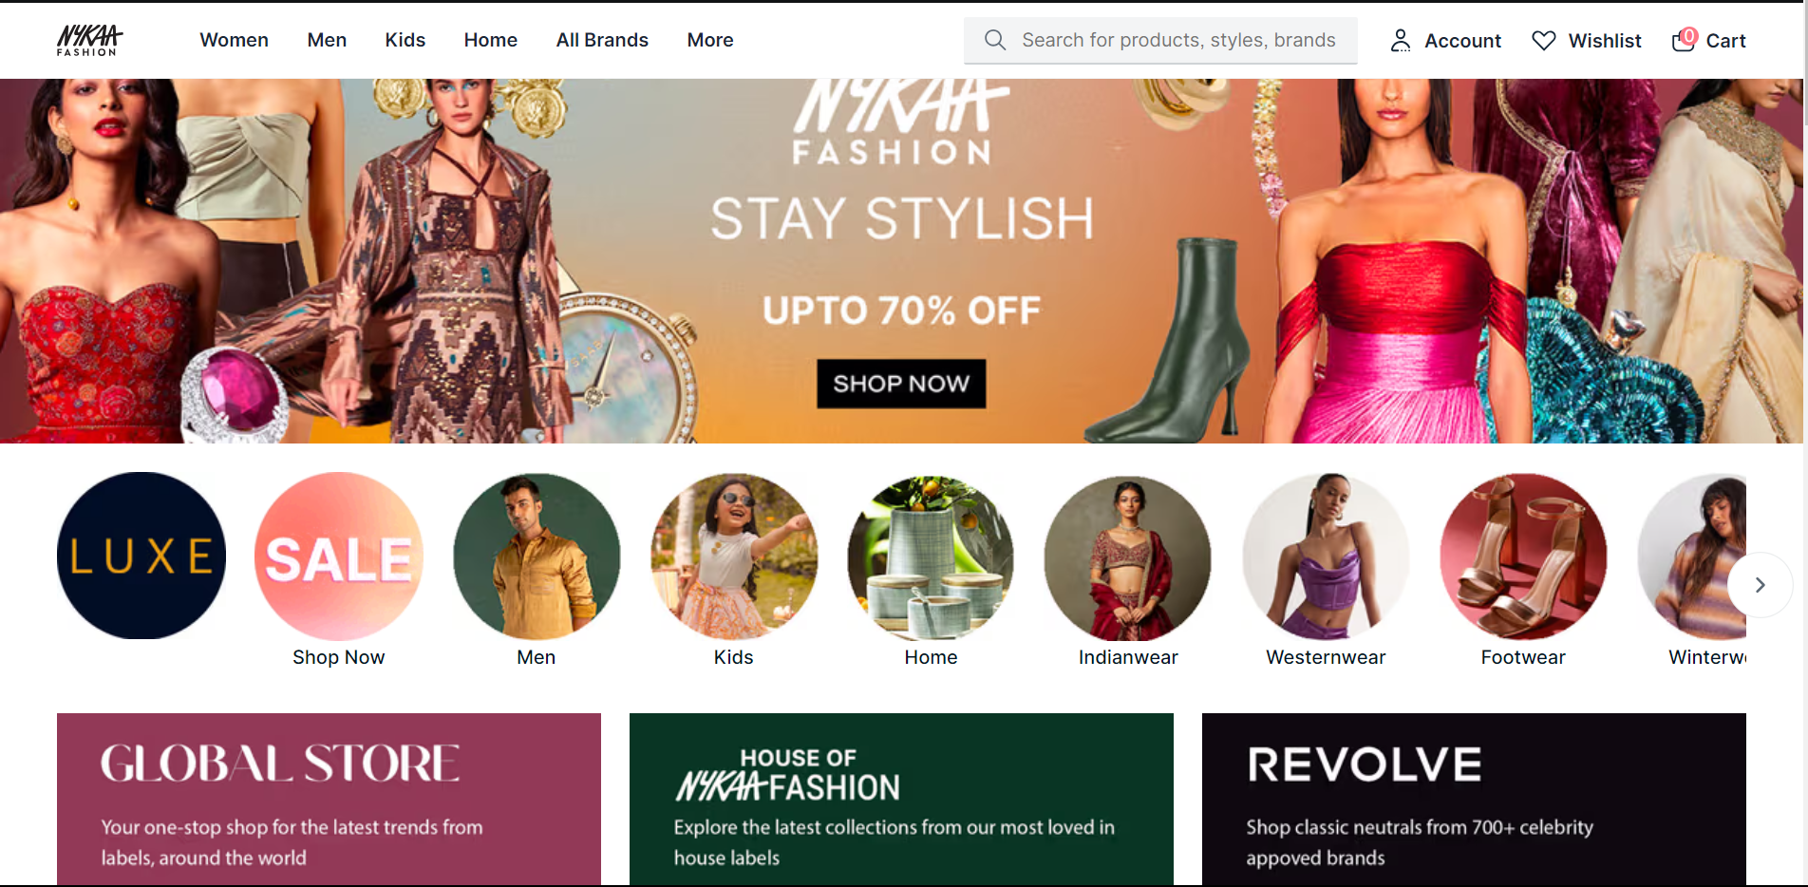

NYKAA

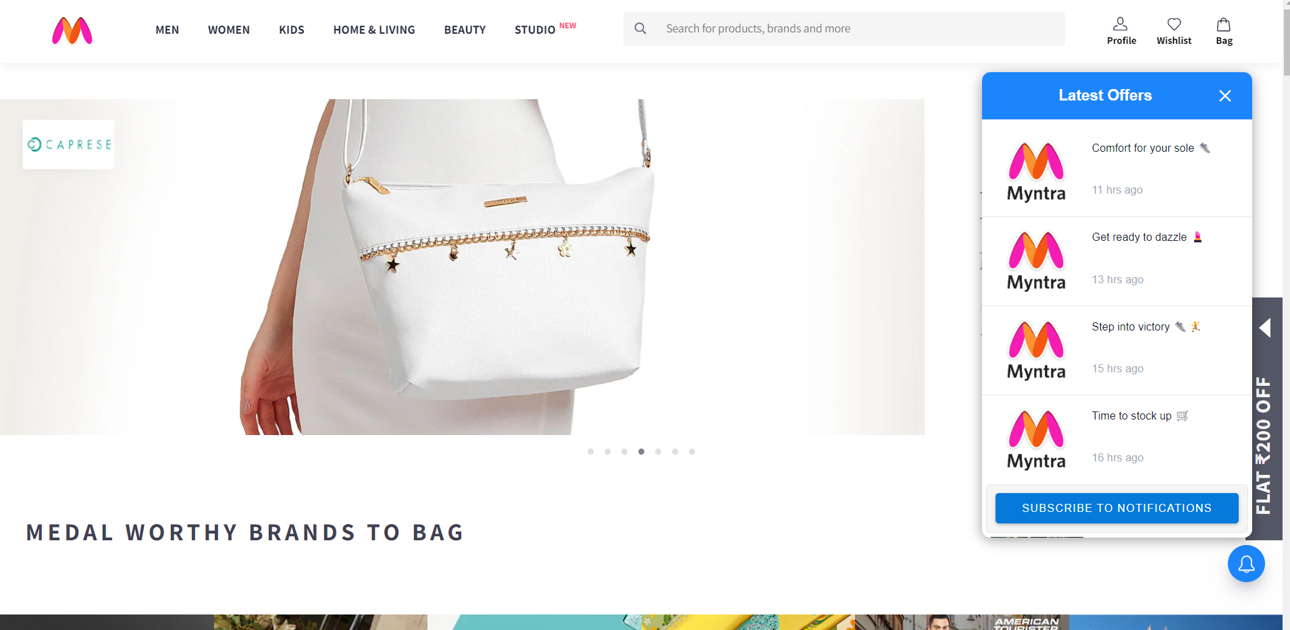

MYNTRA

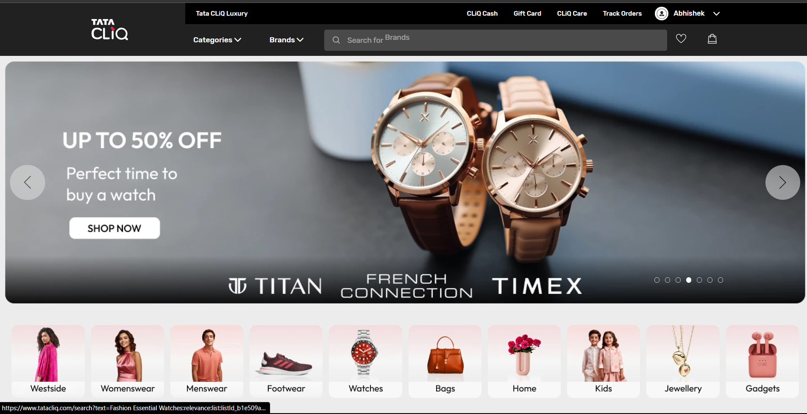

Tata cliq

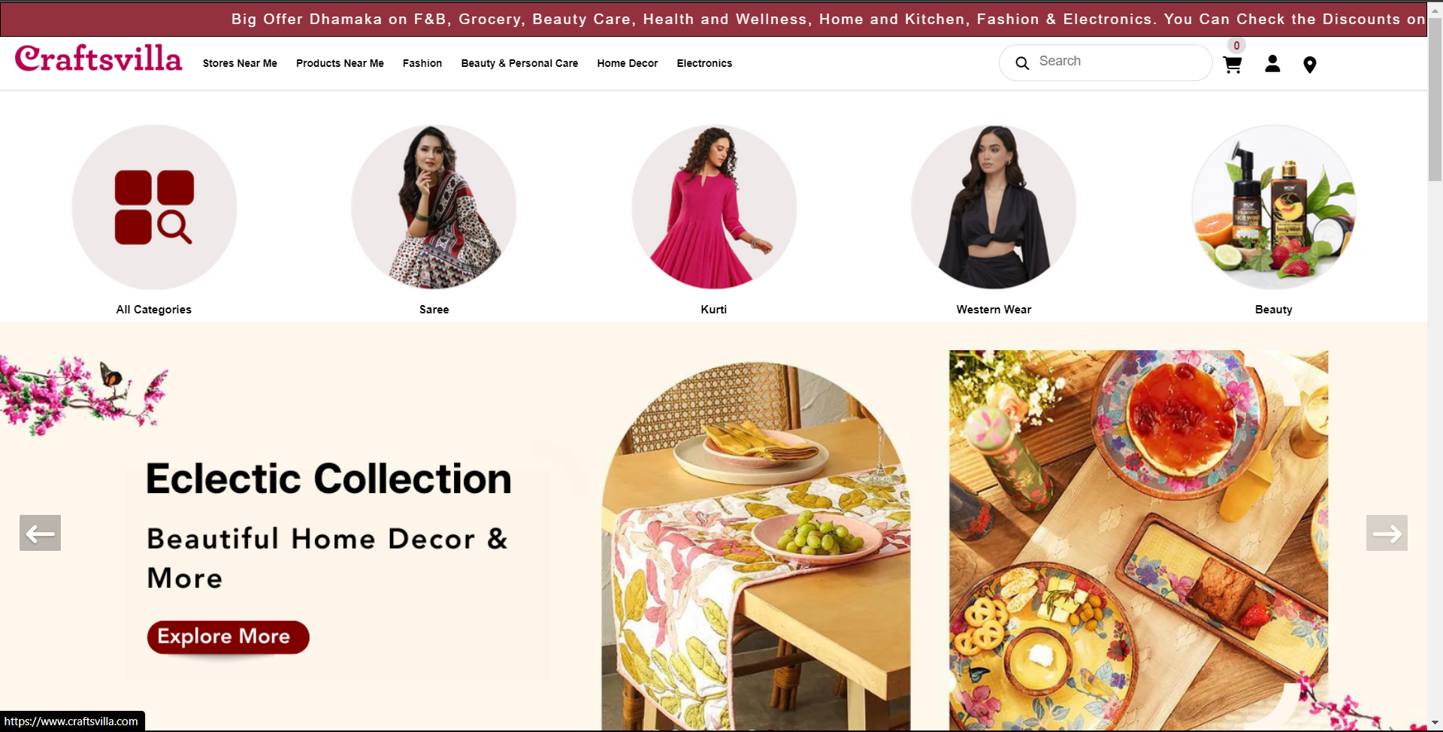

CraftsVilla

| Module-3 Category page |
| --- |

| Sr No | Company | Functionality | Control | Validation |
| --- | --- | --- | --- | --- |
| 1 | AJIO | On the category page we see the selected categories from the dashboard like we select men categories then it shows the men's related things. | Many links for subcategories,like images of shirt,t-shirt,crocs,etc. | NA |
| 2 | NYKAA | On the category page we see the selected categories from the dashboard like we select men categories then it shows the men's related things. | -filter(bar)  -short by(drop down)  -products(img/link) | NA |
| 3 | MYNTRA | On the category page we see the selected categories from the dashboard like we select men categories then it shows the men's related things. | -filter(bar)  -short by(drop down)  -products(img/link) | NA |
| 4 | TATACLIQ | On the category page we see the selected categories from the dashboard like we select men categories then it shows the men's related things. | -filter(bar)  -short by(drop down)  -products(img/link) | NA |
| 5 | CraftsVilla | On the category page we see the selected categories from the dashboard like we select men categories then it shows the men's related things. | -filter(bar)  -short by(drop down)  -products(img/link) | NA |

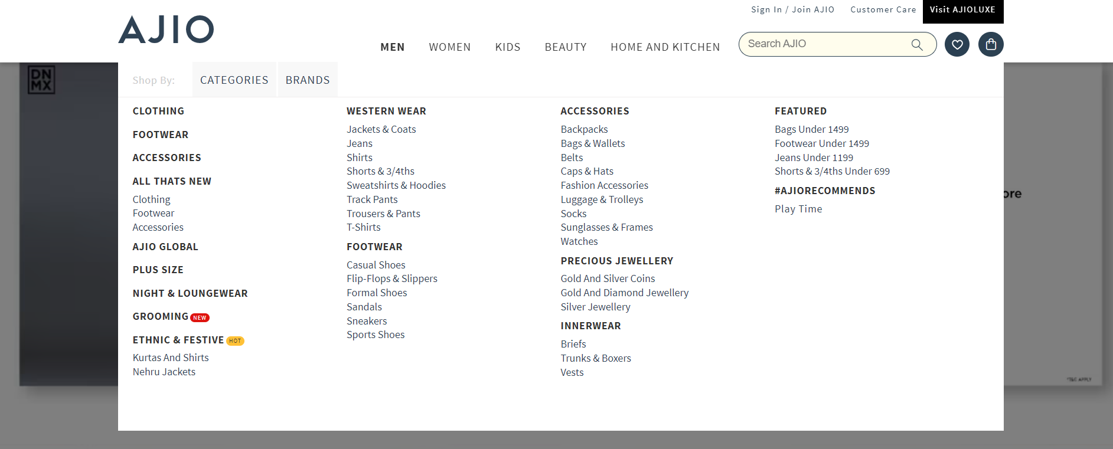

AJIO

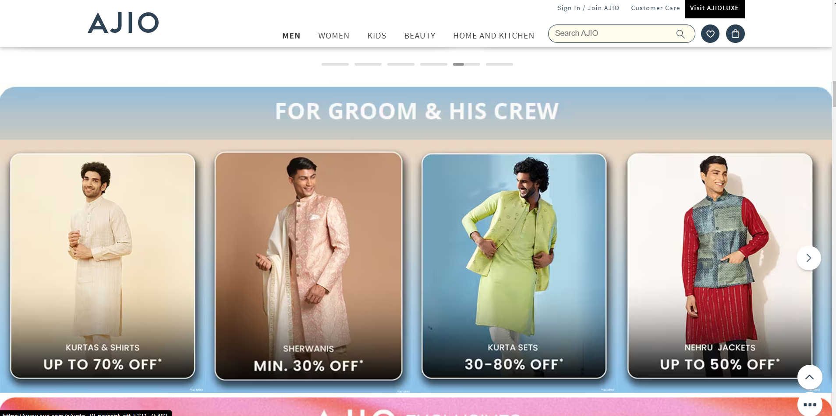

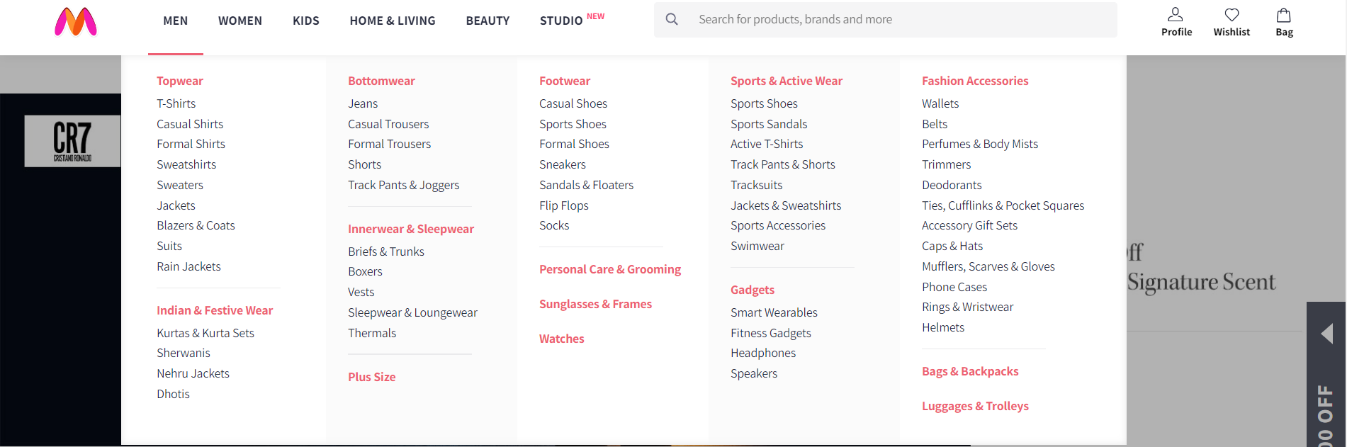

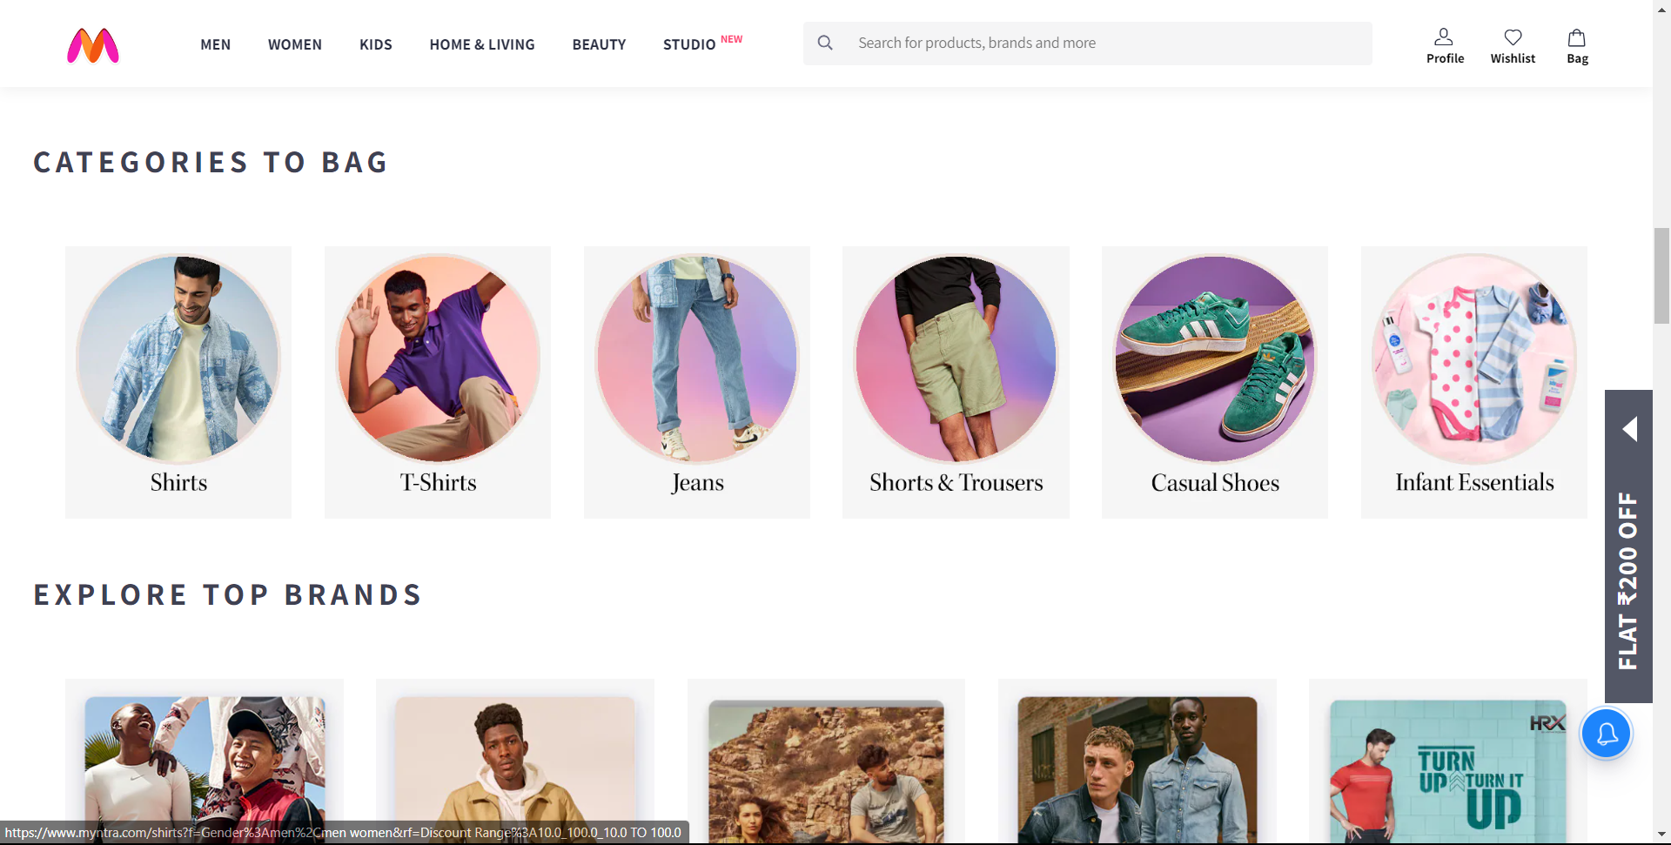

MYNTRA

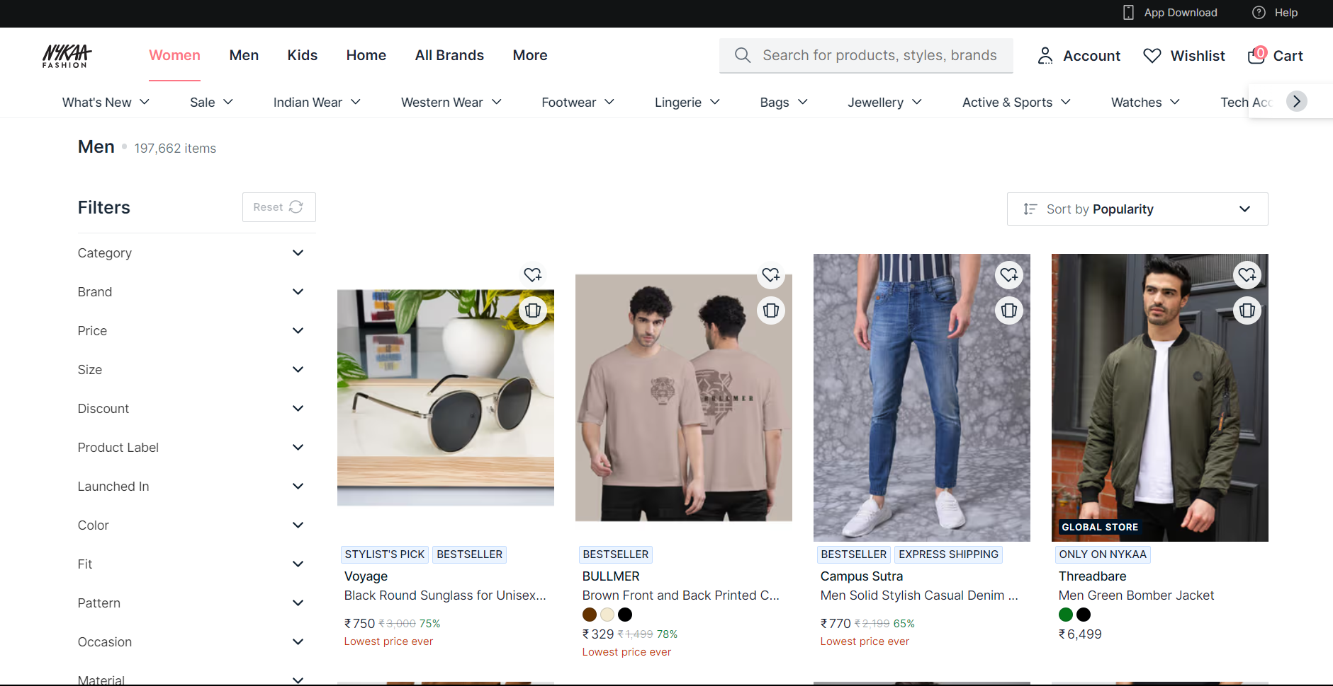

NYKAA

TataCliq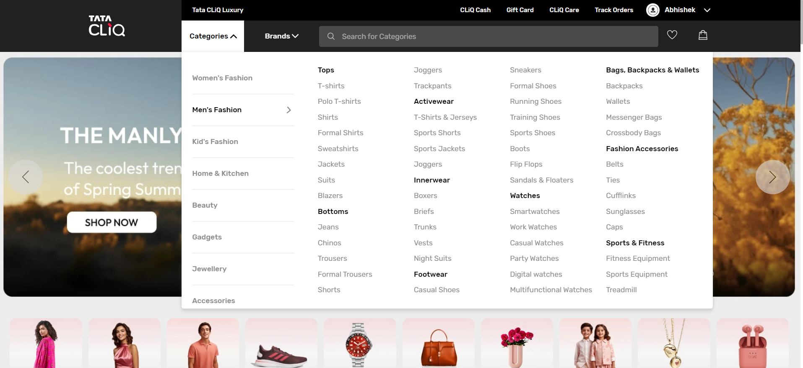

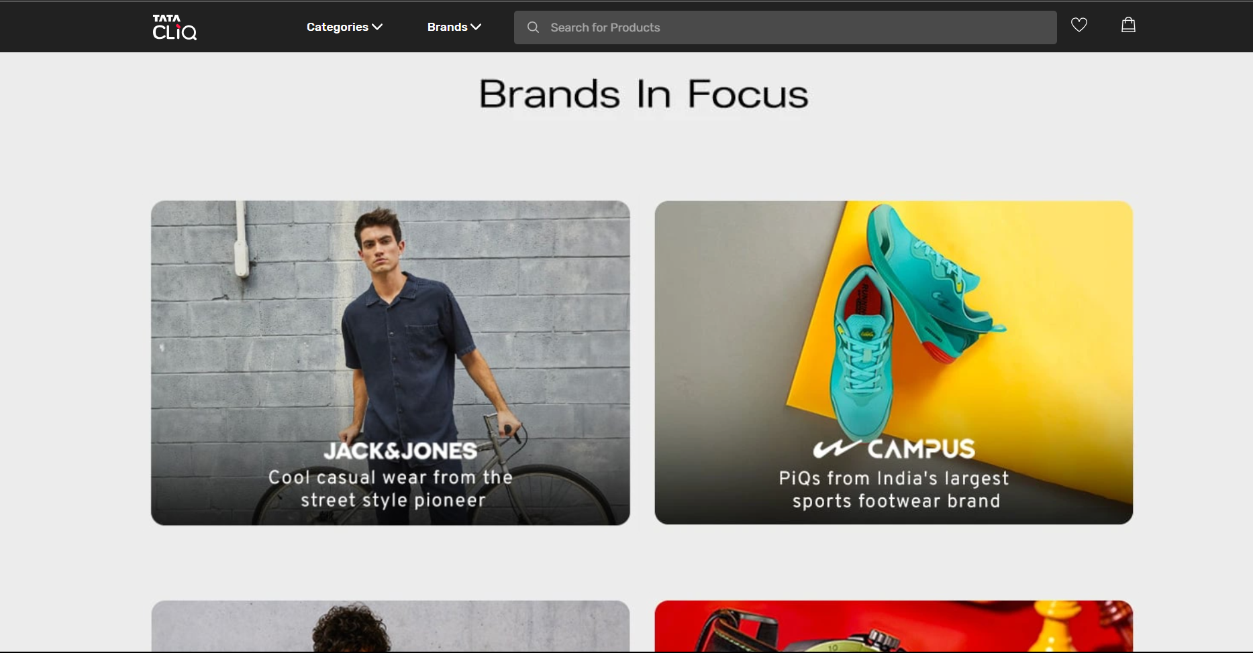

CraftsVilla

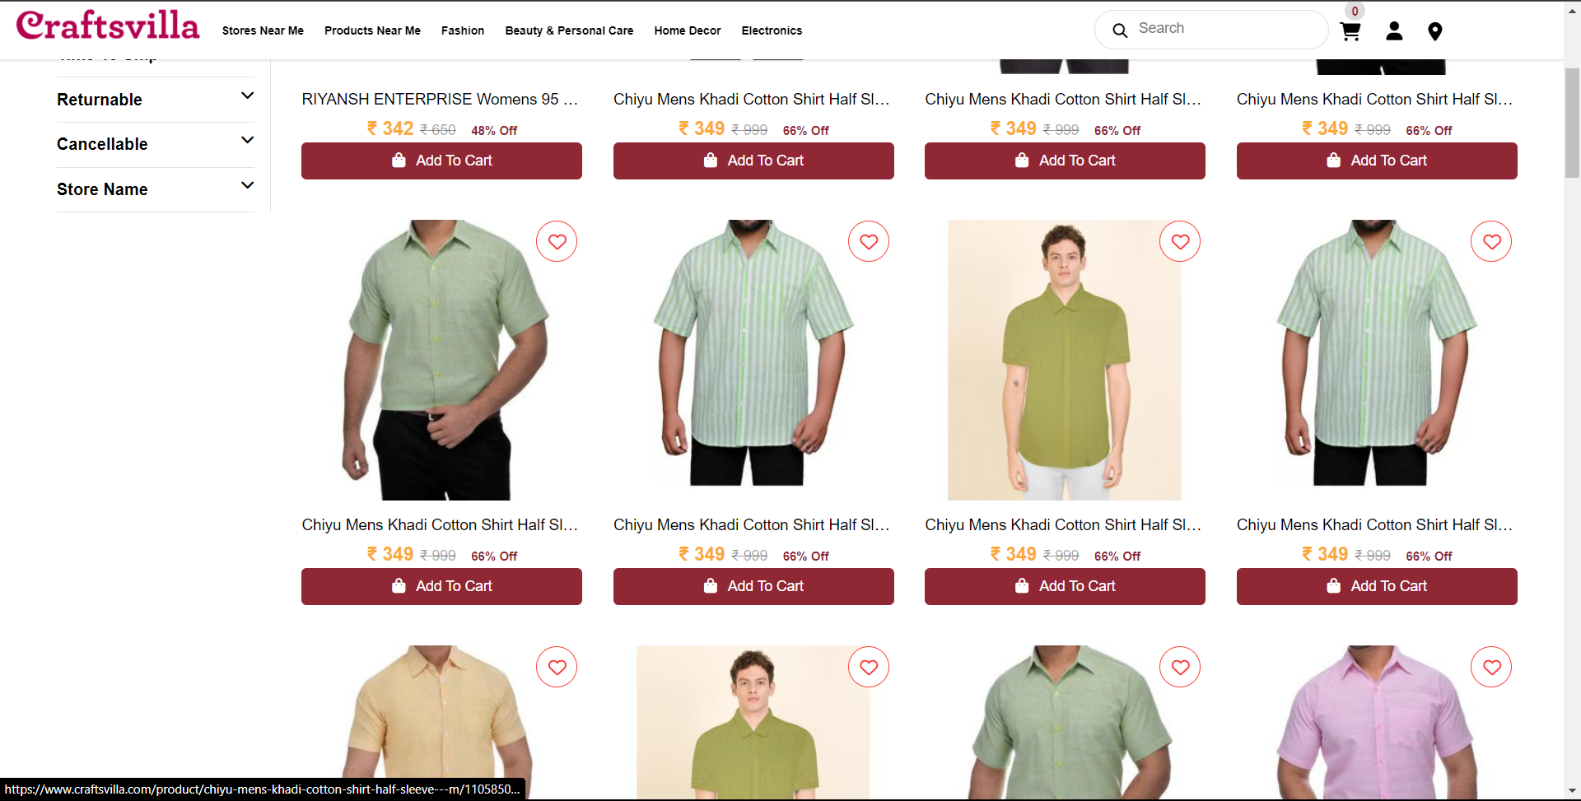

| Module-4 Cart Page |
| --- |

| Sr No. | Company | Functionality | Controls | Validation |
| --- | --- | --- | --- | --- |
| 1 | AJIO | On the cart page users can add the collection of products and then they will purchase them directly from there. | -Cart button(icon button)  -Delete or add(buttons)  -size(navigation)  -proceed to buy(button)  -apply Coupon(link) | NA |
| 2 | NYKAA | On the cart page users can add the collection of products and then they will purchase them directly from there. | -Wishlist(link)  -Proceed to Buy(Button)  -View price details(button)  -Apply Coupon(Button link) | NA |
| 3 | MYNTRA | On the cart page users can add the collection of products and then they will purchase them directly from there. | -Delete or add(buttons)  -size(navigation)  -Place Order(button)  -apply Coupon(link) | NA |
| 4 | TATACLIQ | On the cart page users can add the collection of products and then they will purchase them directly from there. | -Change delivery address(Link)  -quantity(navigation)  -Remove(button)  -Checkout(Button) | NA |
| 5 | CraftsVilla | On the cart page users can add the collection of products and then they will purchase them directly from there. | -Proceed to Checkout(Button)  -Quantity(minus/plus button)  -remove(cross button)  Voice help(button) | NA |

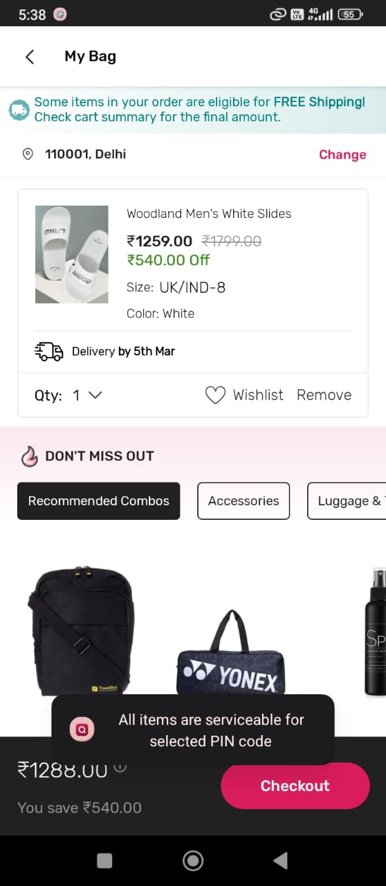

TataCliq

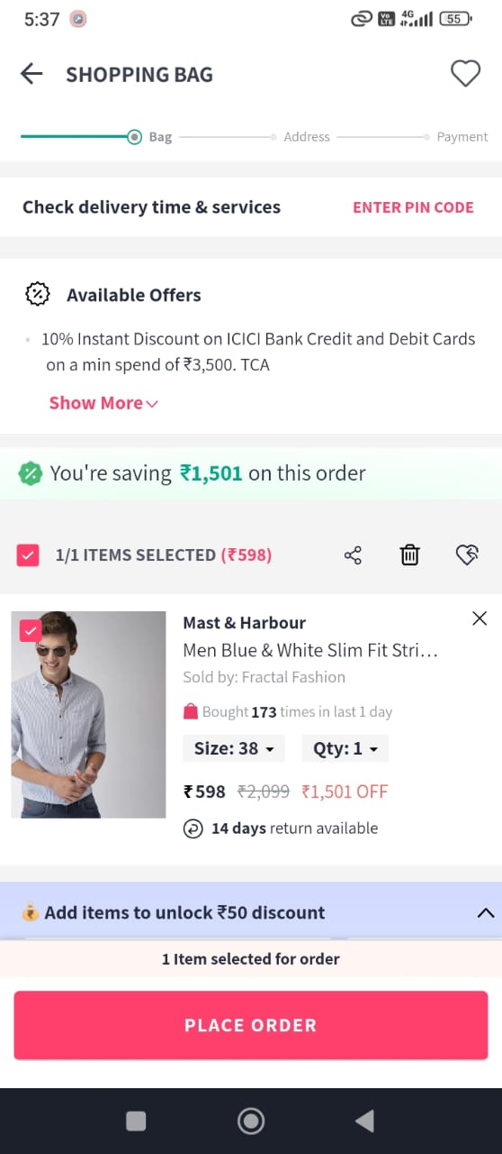

MYNTRA

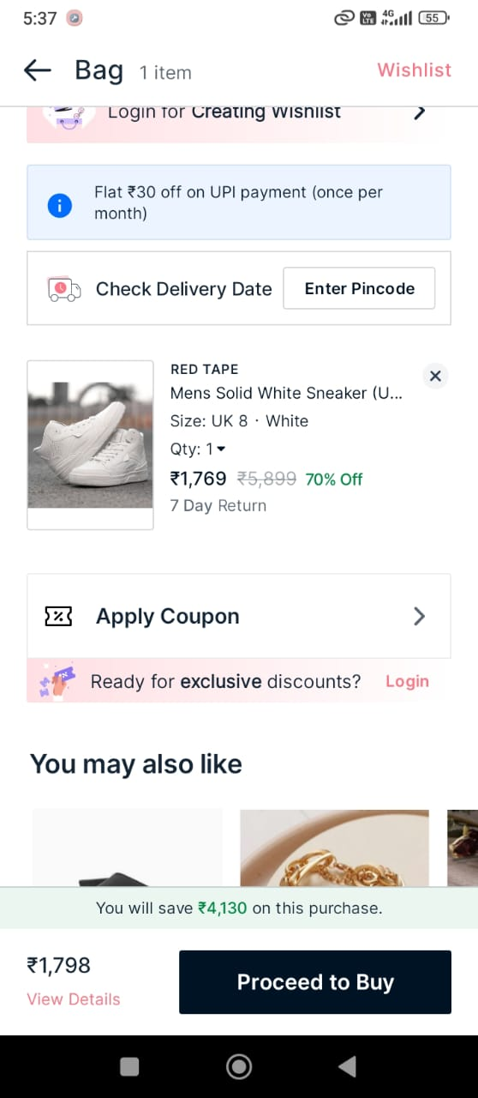

Nykaa

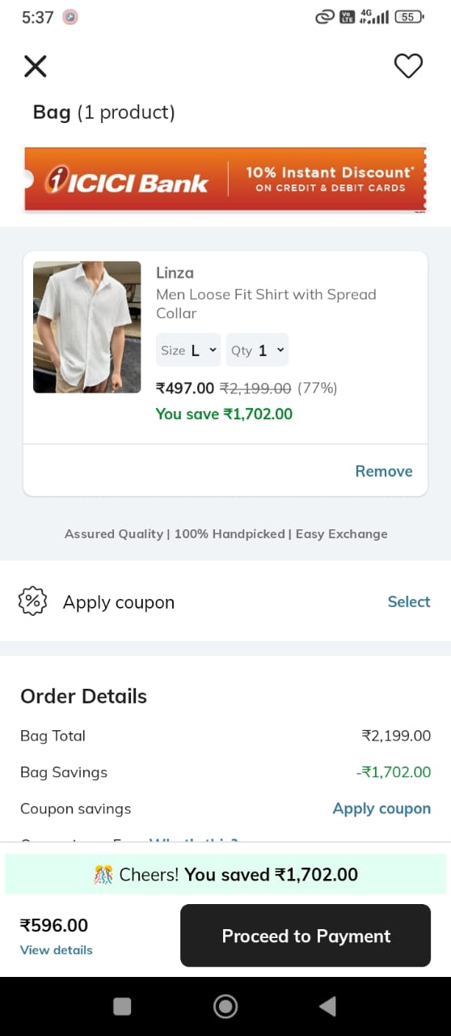

AJIO

CRAFTSVILLA

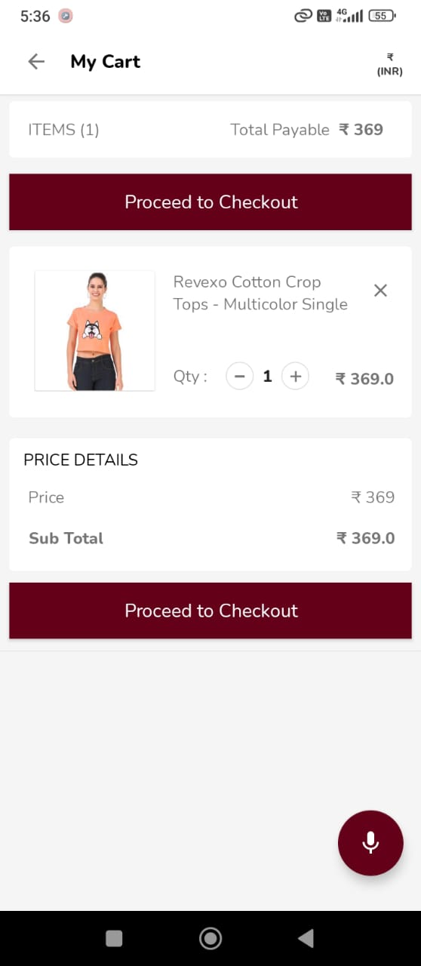

| Module- 5 Order Tracking |
| --- |

| Sr No. | Company | Functionality | Controls | Validation |
| --- | --- | --- | --- | --- |
| 1 | AJIO | An order tracking page is a web-hosted platform that enables customers to track their online orders in real-time | Order Status  Tracking Number  Estimate Delivery Date  Shipping Address  Order Details  Contact Support  Reorder and return Items | NA |
| 2 | NYKAA | An order tracking page is a web-hosted platform that enables customers to track their online orders in real-time | Order Status  Tracking Number  Estimate Delivery Date  Shipping Address  Order Details  Contact Support  Reorder and return Items | NA |
| 3 | MYNTRA | An order tracking page is a web-hosted platform that enables customers to track their online orders in real-time | Order Status  Tracking Number  Estimate Delivery Date  Shipping Address  Order Details  Contact Support  Reorder and return Items | NA |
| 4 | TATACLIQ | An order tracking page is a web-hosted platform that enables customers to track their online orders in real-time | Order Status  Tracking Number  Estimate Delivery Date  Shipping Address  Order Details  Contact Support  Reorder and return Items | NA |
| 5 | CraftsVilla | An order tracking page is a web-hosted platform that enables customers to track their online orders in real-time | Order Status  Tracking Number  Estimate Delivery Date  Shipping Address  Order Details  Contact Support  Reorder and return Items | NA |

| Link of My Figma Design:-<https://www.figma.com/file/faIi4ZVyn5u2Ewcq4tOhyI/FASHION-X?type=design&node-id=0-1&mode=design&t=2Gc3Es3G2nDyBOo1-0> |
| --- |